A Guide to Working with Children whose English is an Additional Language

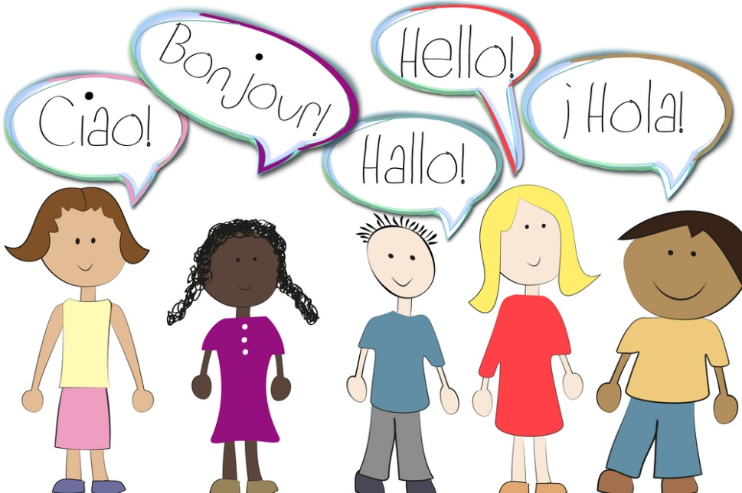

Introduction
This booklet aims to provide information and practical help for staff when a child arrives with little or no English.

Whilst we may encounter some anxieties during the initial settling in period, working with bilingual / emerging bilingual children is a most rewarding experience which will enhance and enrich our setting.

The booklet is divided into the following sections:

- Gathering information

- Cultural differences to look out for

- Creating a welcoming environment

- Early Days in the Classroom

- Providing a language learning environment

I) Receptive language and Communication ii) Games for EAL Learners
iii) Books for EAL Learners

- Partnership with parents and carers

- Frequently Asked Questions

What is the
pupil’s

correct name
and
how
is it
spelt /

pronounced?

Where
exactly
is the family
from?

Who is the

primary
carer?

Are there any

special

circumstances ?

eg Is the pupil an

asylum seeker / adopted
/ from war zone

What
language(s)
are
spoken
at
home?

What is the

parent’s / carer’s
knowledge
of

English?

What
previous

experience
does the
child have of

pre school
in UK or
elsewhere?

Does the pupil have
older / younger

siblings
? Are they

living at home /
elsewhere?

Are there
other

family members /
friends living
nearby?

Does the family

read /
write
in the
home

language?

What is the

family’s

religion?

Is there a
dress

code
or
dietary

requirements?

?

?

?

?

?

?

?

?

?

?

?

?

?

What is the
child’s
knowledge
of

English?

1. Gathering Information

This co
uld be achieved using the Registration Form

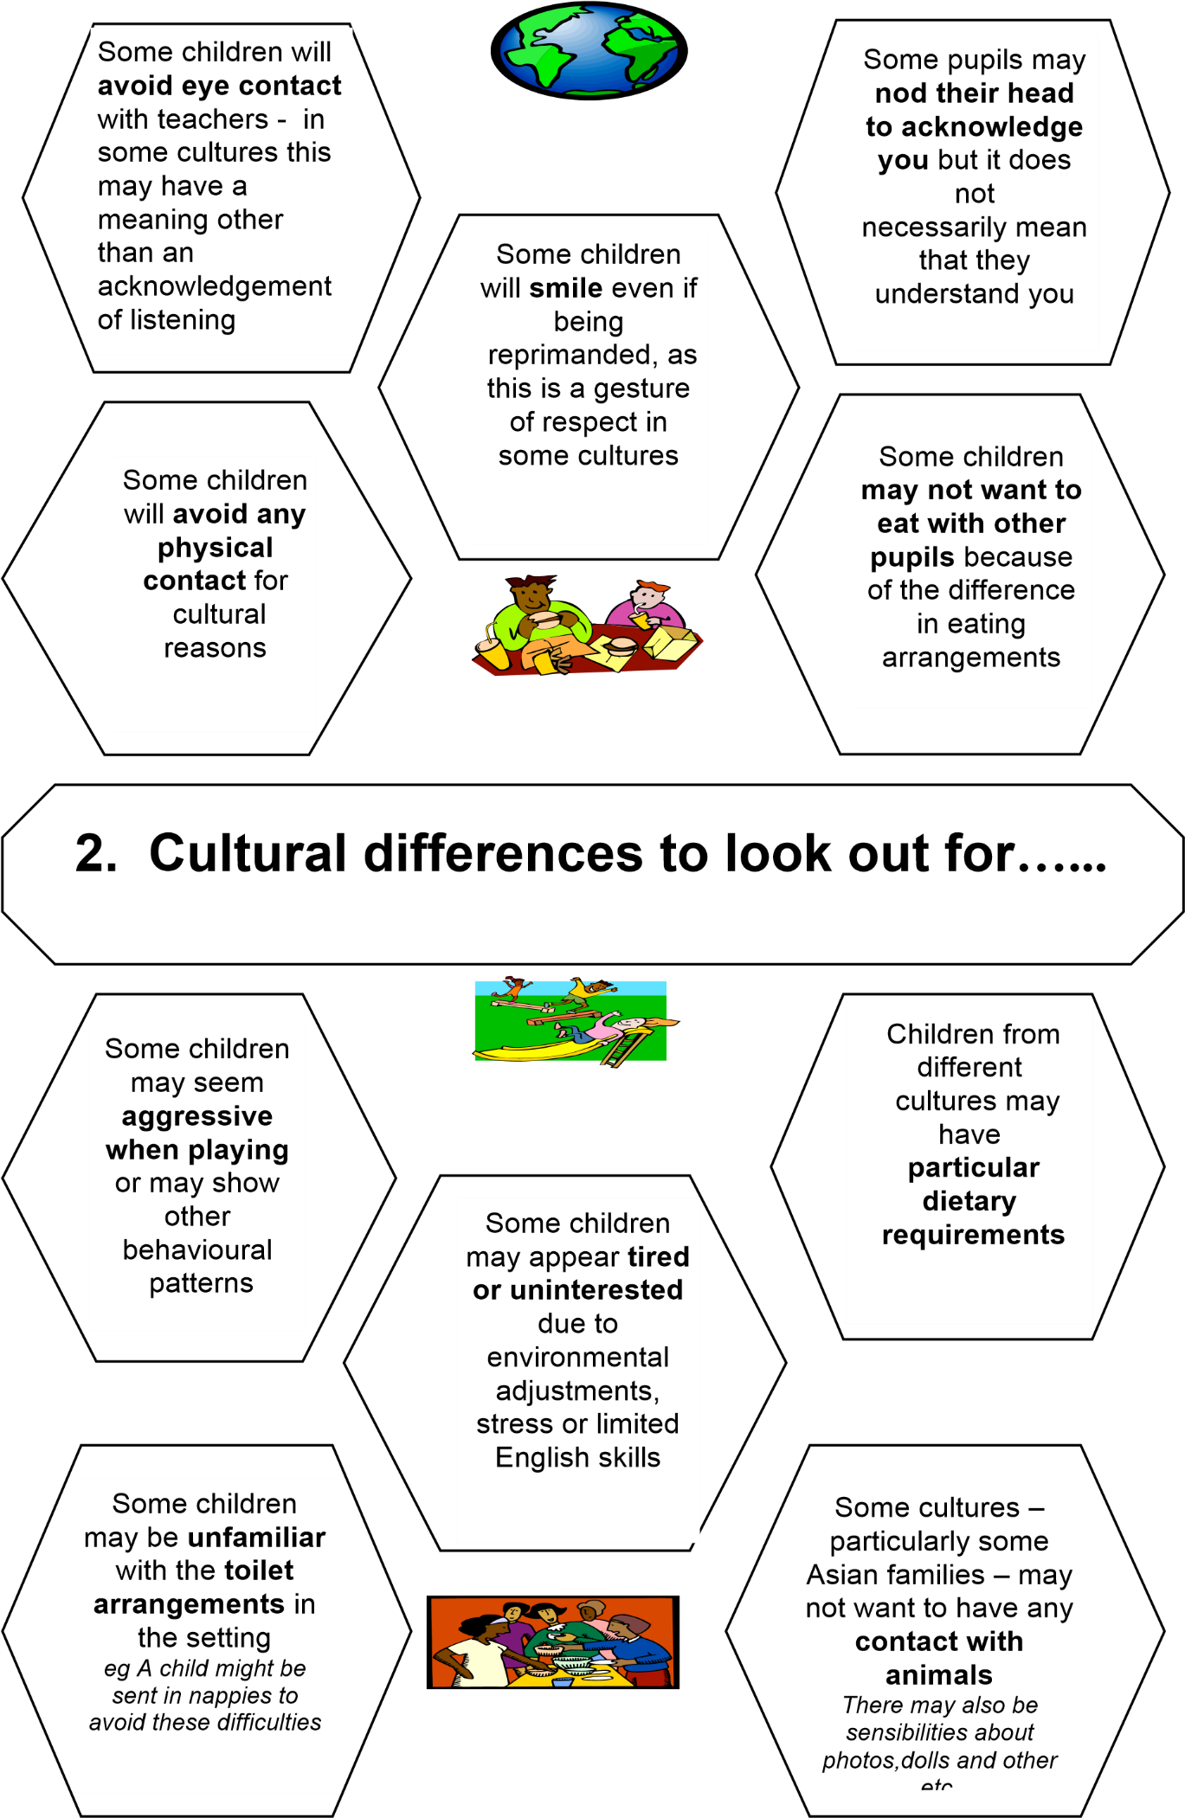

Have

examples
of
writing
eg
labels, notices

that the
child may recognise from
home to show that their
language is valued

and to help other children
to learn to value other
languages and
scripts

Establish

a
consistent

set of
routines

eg snack
time, circle ti
me
and
provide

cues
such as to
what happens when
eg a frieze showing
daily routine in

pictorial form- visual timetable

3
. Creating a welcoming environment

Ensure

that the EAL child’s
home life
is reflected in
the setting
eg include
familiar cooking
equipment
/
food
items
in the role play
area

*See appendix for
example

Have some

dual

language books

for parents / carer
and
others to share.

Share some
rhymes
in
other languages.

Learn to count

in other languages

Explain

to the children that some
children speak other
languages.
Encourage

them to
interact
with
them. Help them to

understand that
non
respo
nse
is not social

rejection but lack of

comprehension

Have

Welcome Posters, and
And
other visuals around the
walls to
reflect different
cultures
.

Display children’s own
named photoes
to give
everyone a
sense of
belonging

3i) Early Days in the Classroom

Essential language

Basic words and phrases to enable the newcomer to function day to day and to express immediate needs in the first few days and weeks

Hello
Yes
No
Please may I have…
Thank you
Goodbye
I need to go to the toilet
I like..
I don’t like
Where is……
I don’t understand
With a ‘buddy’ the  EAL learner can label different things  in the classroom to help him /her remember the words |  |  |  | Start an alphabet/ topic word book with pictures and add to it as a new word is learnt |  |  |  | Play Circle games or Simon Says which allow  participation with the minimum of  speaking |  |  |  | Have a box of resources ready to dip into eg. PECs, pictures, now and next board, wordless  books, toys, visual support, bilingual  story books + tapes  *see resource page
 |  | Staff to run a small group to work on extending their vocabulary and developing language |  |  |  | Provide magazines and catalogues to  cut out pictures to sort and categorise for word books, displays |  |  |  | Make our own Nursery book . Take photos around the centre  to illustrate  places, activities, daily routine
 | Be prepared for children to spend long periods in solitary play at first |  |  |  |  |  | Children need opportunities to start to interact with others through  conversation. This can be in planned  learning opportunities or informal situations
 | By watching others involved in an learning opportunity children have access to good language and will be tuning in to the language around them
Think carefully about using questions that will include the information
needed in a response. eg Ask “Would you like a green one or a blue one? rather than “Which colour would you like?” Use gestures to reinforce

When planning sessions, make a note of how the learning opportunities can provide
language learning opportunities for the EAL children

Provide opportunities to share books
1:1 with EAL children to allow them to encounter “book” language

4. Providing a positive and encouraging Language Learning Environment

Support this through pictures, symbols and gestures wherever possible

Speak clearly, EAL learners need to hear English spoken  as normally as possible – if sentences  are over simplified or loudly stressed this may make understanding more difficult |  | Use gestures / visuals / props / puppets / other adults or children as  models in order to help explain what  you are talking about
NARATE EVERYTHING  “Talk while doing” to model appropriate language eg while playing a game or putting a coat on |  | Accept any speech without correcting, praise and then model  words for children – encourage but do not require repetition of models
Use the home corner to reflect different cultural backgrounds and encourage  talk about familiar activities eg cooking,  eating |  | Use songs and rhymes to provide a learning opportunity to join in a few words and extend their language in a encouraging and positive environment

4i) Receptive Language and Communication

The EAL Beginner will be watching / listening to the adults and other children around him / her – it is really important to support talk/ communication with visuals / materials / actions / gestures/ resources wherever possible to help convey meaning. Here are some examples of language areas that can be developed quite naturally during the course of everyday activities in the setting.

Greet people, respond to greetings | Hello….How are you?  Fine, thank you….OK
Express agreement / disagreement | Yes….No…..  I like / don’t like
Identify objects and people | What’s this? Who’s this?  This is a….. It’s…...  They’re…...
Answer and ask questions about physical characteristics and feelings | I’ve got black hair.  She is tall.  I’m cold / hungry / happy / sad
Answer and ask questions about number | How many pencils?  I’ve got two sisters  There are six boys
Answer and ask questions about possession | I’ve got a …….  This is my bag.  Whose coat is this?
Answer and ask questions about where things are | Where’s the book?  (It’s) in / on / under / behind  The chair is by the table
Express simple actions | What are you doing?  What is s/he doing?  I’m…...ing S/he’s…..ing

Basic Topic Areas
Ourselves | Personal details Family Feelings / Needs Home Clothes Food Parts of the Body
Setting / Centre | The Environment eg rooms, gardens, furniture, toys  People who work with us
Mathematical  Development | Numbers Shapes Size Money Time
Other Topics | Colours Animals Transport In the Town / Country Occupations Shopping Weather

4ii) Games for EAL Learners

Games introduce new vocabulary, new concepts, use of number, social language. Remember to include children in the group who will provide good language models

Examples:
Many of these games will be well known in the setting.
This is by no means an exhaustive list and you will no doubt know others and have particular favourites, but it serves to illustrate how to find language learning opportunities among readily available resources

Language / Vocabulary Focus Colours, dice, your / my turn, throw, board, put common nouns
Common nouns
Common verbs and nouns
Common nouns
Positional language, Where…? Home / In the street

Parts of the body, clothes, animals
Food, like / dislike
Instructions, parts of the body
Common nouns, language of size Front / back, push / pull, over /under

Common nouns, food, transport, animals

Colours,

Colour, parts of house, shape
Common nouns
Various common scenes – school, home, farm, shop, seaside
Book language, common nouns, Names of people
Physical descriptions- any set of objects eg toys, equipment / animals / vehicles
Common supermarket items

Directions, counting, taking turns

Games
Match –a – Balloon

Picture Lotto / Matching Pairs
Picture Snap
Sound Lotto
What Belongs Where ? (Spectrum)

Animal / People Jigsaw Puzzles
Tummyache Game
Simon Says
Size Lotto
Teddy Bear Opposites ( Orchard
Toys)
The If….Game (Philip and Tacey)

Teddy Bears Colour Match Express
(Orchard Toys)
The house that Jack Built
Picture Dominoes
Press & Peel

Magnetic Storyboard with story packs
Guess Who?
What’s in the Bag?

The Shopping List Game

4iii) Books for EAL Learners

Choose books with very little text, but which are clearly supported by strong visual impact.

The best stories, rhymes are those with repetitive or predictable storylines / refrains.

Choose books that relate to children’s experience which provide positive images and value cultural diversity.

Wordless Picture Books are ideal for “reading” in any language. They can be used to introduce new words or explore culture specific references.

Many stories have audio taped versions to enable the pupil to see and hear the language simultaneously. Talking books can be found on the internet, including some dual language texts. You can also make your own resources using different recording devices such as talking clipboards, talking pegs etc

More and more books are being produced in dual language text. These are equally valuable for sharing with children who speak one language.

Home made books are easy and inexpensive to make and can be used to support the curriculum in many ways. They can be both fiction and non fiction. They can provide an important link between home / school. Bilingual versions can be produced with help from home or other bilingual speakers
Here are some books for the EAL Beginner, but you will be able to think of many more that will be equally suitable

Mr Gumpy’s Outing  The Shopping Basket | John Burningham
Dear Zoo | Rod Campbell
How Do I Put It On  How Do I Eat It | Shigeo Watanabe
Peace at Last | Jill Murphy
The Snowman | Raymond Briggs
A Dark, Dark Tale | Ruth Brown
Spot books Eric Hill

Brown Bear, Brown Bear Eric Carle
The Very Hungry Caterpillar

Rosie’s Walk Pat Hutchins
Titch

Handa’s Surprise Eileen
Browne

Lima’s Red Hot Chilli David Mills

5. Partnership with Parents and Carers

Parents, carers need to see how supported play/activities/ learning opportunities can provide opportunities to model, rehearse and extend language.

Let parents’ to come into the setting and join inExplain newsletters/ notes verbally if at all possible as this will enable you to be sure that the parents/ carers have understood the content and may help to avoid misunderstandings e.g notices about special events, requests for extra help/items needed for a particular activity etc.

Information for parents may be available in other languages – particularly the main community languages in Reading, however, not all people who speak a language are literate in it, so it is useful if you can find another family member/friend who can act as interpreter if necessary. It is also possible to contact local community/ language groups in the county.

Encourage parents and carers to join in sessions. This will give them the opportunity to experience what happens and to be able to share/talk about activities with their child in the first language. Remember, parents/carers may be feeling isolated in the community or have little/very different experience of Early Years Education themselves

6. Frequently asked questions
Q. How do we convey an urgent message to parents where we are uncertain of their understanding?
A. If you feel that a phone message in English may not be understood, try to get a contact number of someone who will be able to translate – eg work colleague, parents, friends or community organisation.

Q. How do we find out about availability of interpretation?
A. Contact Katarina to arrange an interpreter if possible.

Q. Why won’t a child talk to me when I’ve heard them talking freely with other children?
A. Children may appear quickly to develop language for social communication ie for regularly encountered play situations. This may be largely based on echoing the language around them, until by trial and error, what they say achieves the desired effect. They will be beginning to understand some other talk directed at them, but may not yet be ready to produce a reply or “make conversation” themselves. Don’t give up talking to them; they will sooner or later begin to make sense of what you are saying, and may even surprise you by uttering a complete sentence after weeks or even months of silence!

Q. Should I put a child on the SEN register because he / she has EAL?
A. EAL does not mean that a child has SEND. However, refer to The Code of Practice and EYFS which can be found on our website.

Q. What do I do if children refuse to play with or make unkind / hurtful remarks about the EAL child ie about their inability to “talk properly”, about their skin colour or any other perceived differences?
A. Such incidents should be dealt with immediately in order to show that such behaviour is not acceptable. Above all, do not pretend that the problem will go away. Such behaviour is bullying and its hurtful effects should be acknowledged and dealt with.

Above all

BE FRIENDLY- a welcoming gesture, smiling face, encouragement and positive praise can be worth a thousand words!

Invest time getting to know parents and careers- it may be difficult to build links if they have little or no English but it is important that they feel valued and reassured about the well being of their children.

Becoming more familiar with the family will help you a better understand potential cultural/religious/home circumstances that may need to be taken into account in planning an inclusive learning environment. The family’s Health Visitor/ Portage Worker may be a good source of information gathered over a period of time.

It is important that everybody realises that the development of the child’s first language is vital in learning English-talking about things in the child’s home language with parents/carers will really help them to make sense of the English around them and build on the language they are beginning to acquire.

